**CloudX Solutions: Streamlined Password Management for Secure Cloud Operations**

**Problem Statement:**

CloudX Solutions, a rapidly growing cloud service provider, faced challenges in securely managing AWS access for an IAM user requiring password-based authentication to manage critical cloud resources. Manually handling credentials created inefficiencies and increased the risk of unauthorized access. To address this, CloudX Solutions initiated a project to create an IAM user with self-managed password capabilities, ensuring compliance with security policies and reducing administrative overhead. The project focuses on implementing a secure, scalable access management solution that enforces the principle of least privilege, granting the user only the necessary permissions while maintaining flexibility for future growth. This approach ensures secure and efficient cloud operations while safeguarding sensitive assets.



**Pre-requisites:**

### 1. AWS Account Setup: [https://youtu.be/CjKhQoYeR4Q?si=ui8Bvk_M4FfVM-D](https://youtu.be/CjKhQoYeR4Q?si=ui8Bvk_M4FfVM-Dh)h

### 2. Understanding of IAM: <https://youtu.be/gsgdAyGhV0o?si=3qg-bULgkD4LXNvR>

3. Region Selection :<https://youtu.be/NQhH2kcKI5U?si=GwDI8Gx7oUot8PiT>

**Objective:**

The objective of this project is to design and implement a secure and scalable access management solution for CloudX Solutions, enabling an IAM user to effectively manage their password while adhering to the principle of least privilege. The solution aims to streamline user access to critical AWS resources, ensuring that the user has the necessary permissions to perform their role without compromising security. By allowing the IAM user to manage their own credentials, the project seeks to reduce administrative overhead, mitigate security risks, and ensure compliance with internal security policies. The ultimate goal is to maintain efficient cloud operations while safeguarding sensitive resources and creating a flexible framework that can be scaled for future organizational growth.

**Tasks:**

1. Log in to AWS Management Console and go to **IAM service**.
2. Click **"Add user"** and set a unique username.
3. Check **"AWS Management Console access"** and choose **"IAM user"**.
4. Attach the **IAMUserChangePassword** permission policy.
5. Optionally, add tags for organization.
6. Review the details and click **"Create user"**.
7. Retrieve login credentials and sign-in URL.
8. Log in as the user and confirm the ability to change the password.

**Solution Development Procedure:**

1. Log in to AWS Management Console and go to **IAM service**.

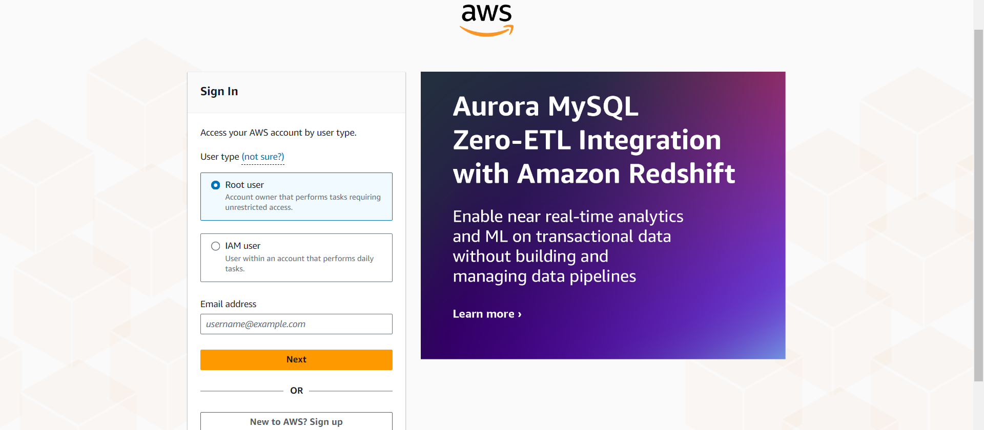

AWS sign-in page where the user selects between signing in as a **Root user** or an **IAM user**. This is the initial step for accessing the AWS Management Console.

-To create an IAM user select Root User

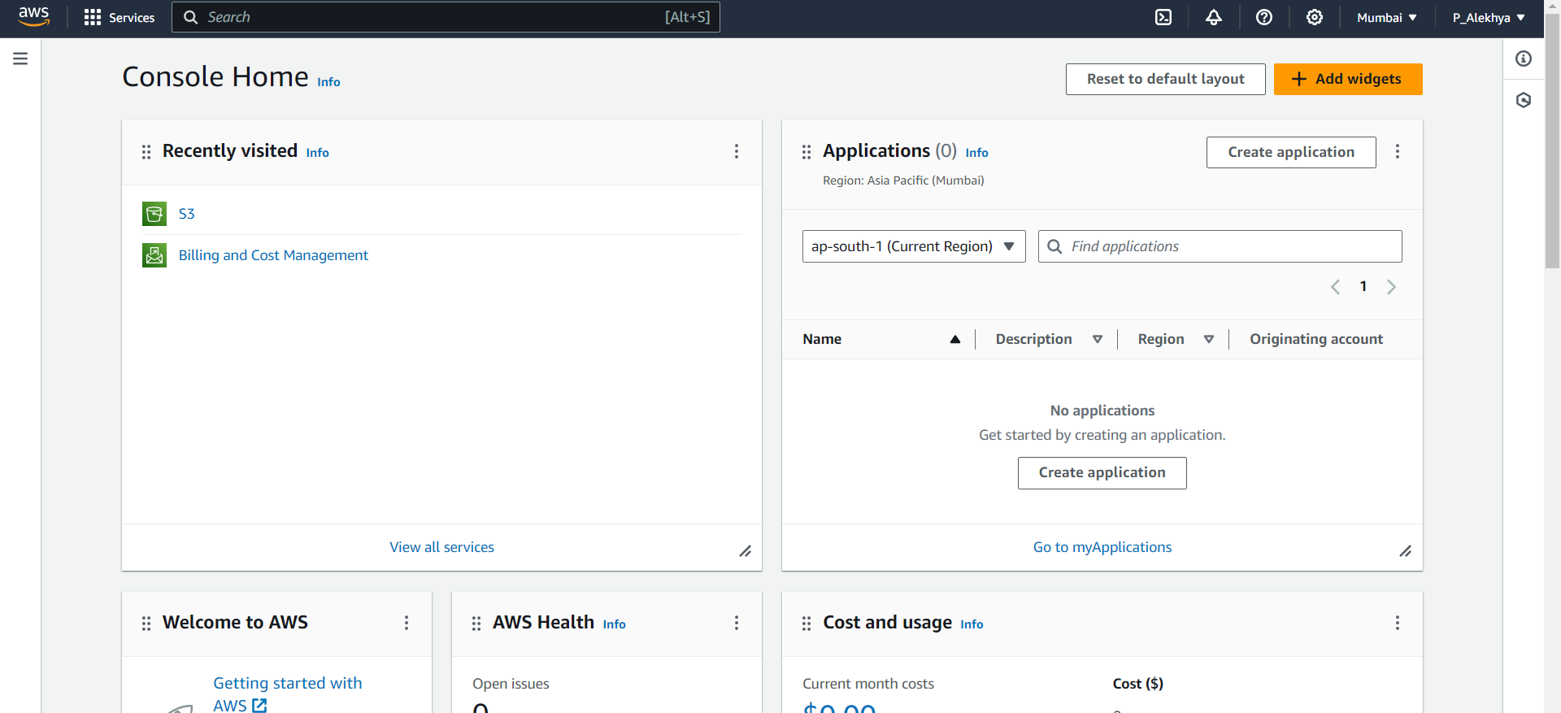

AWS Console Home page after login, displaying recently accessed services , along with an overview of the account’s activities.

* By navigating to the search bar ,we could find desired services.

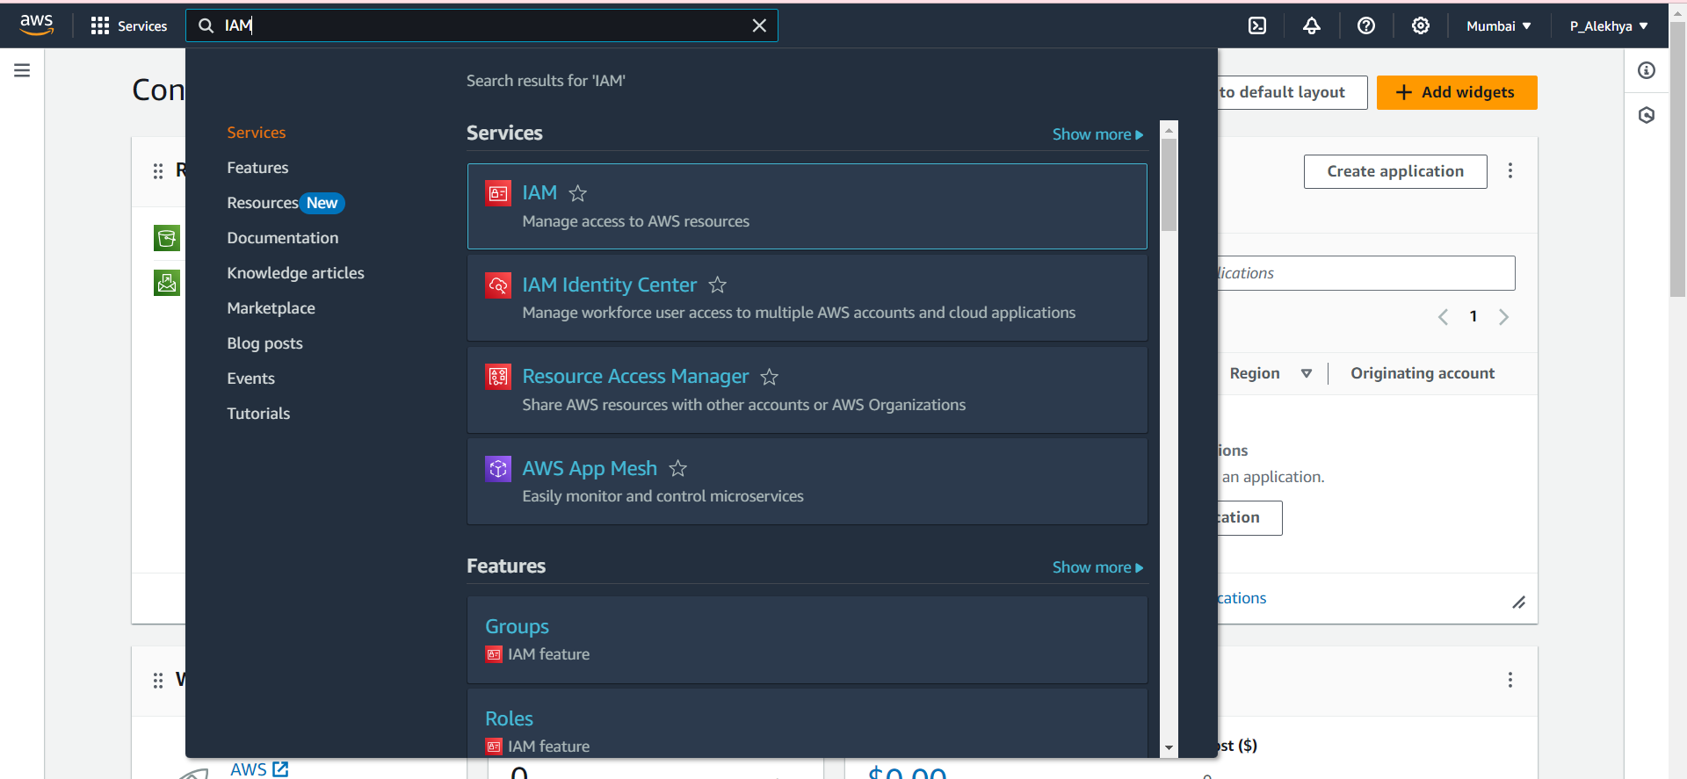

AWS search bar being used to look for **IAM** (Identity and Access Management) services. This enables quick navigation to the IAM dashboard.

* Select IAM Service ,which is at the top.

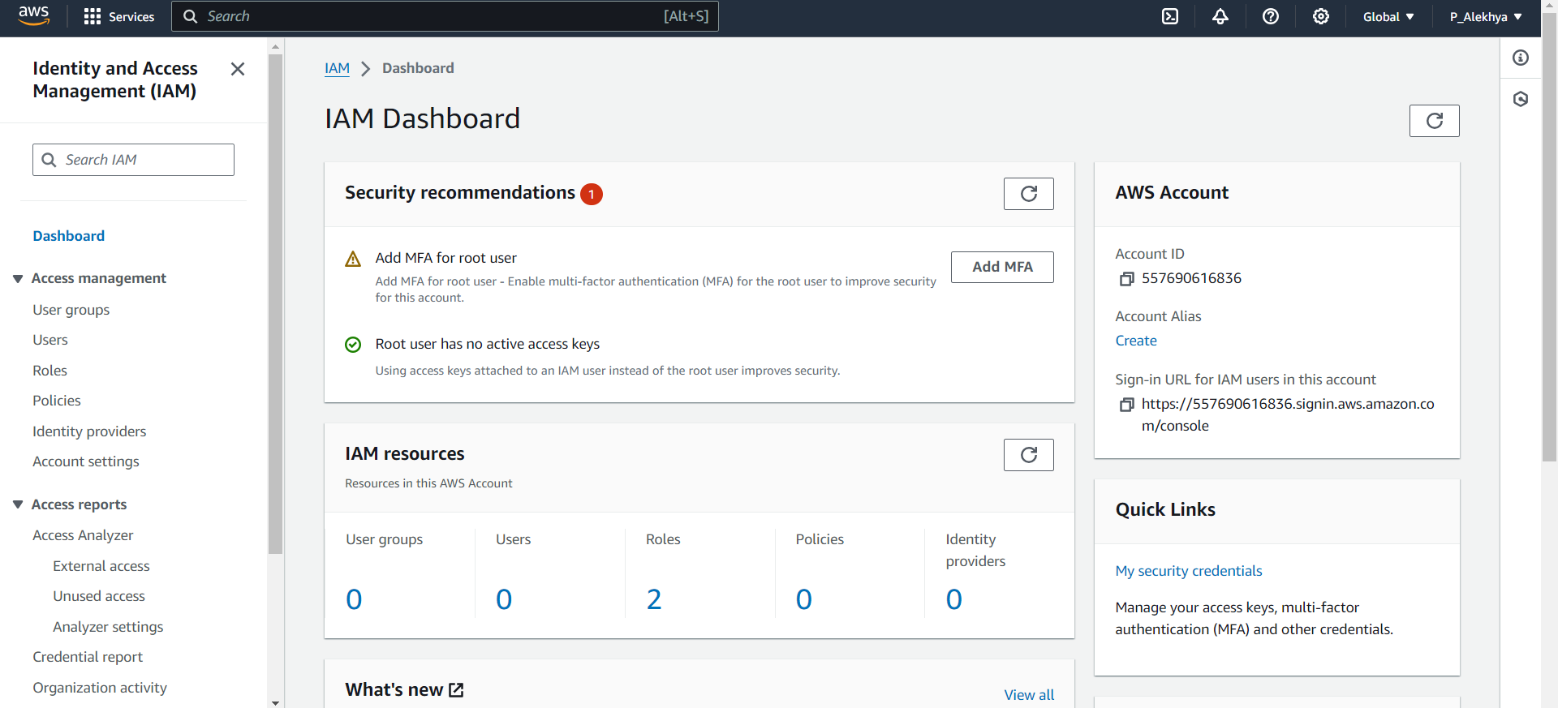

The **IAM Dashboard**, showing important security recommendations, such as enabling MFA for the root user, and displaying an overview of existing IAM resources like users, roles, and policies.

* Click on Users,to create an IAM User.

1. Click **"Add user"** and set a unique username.

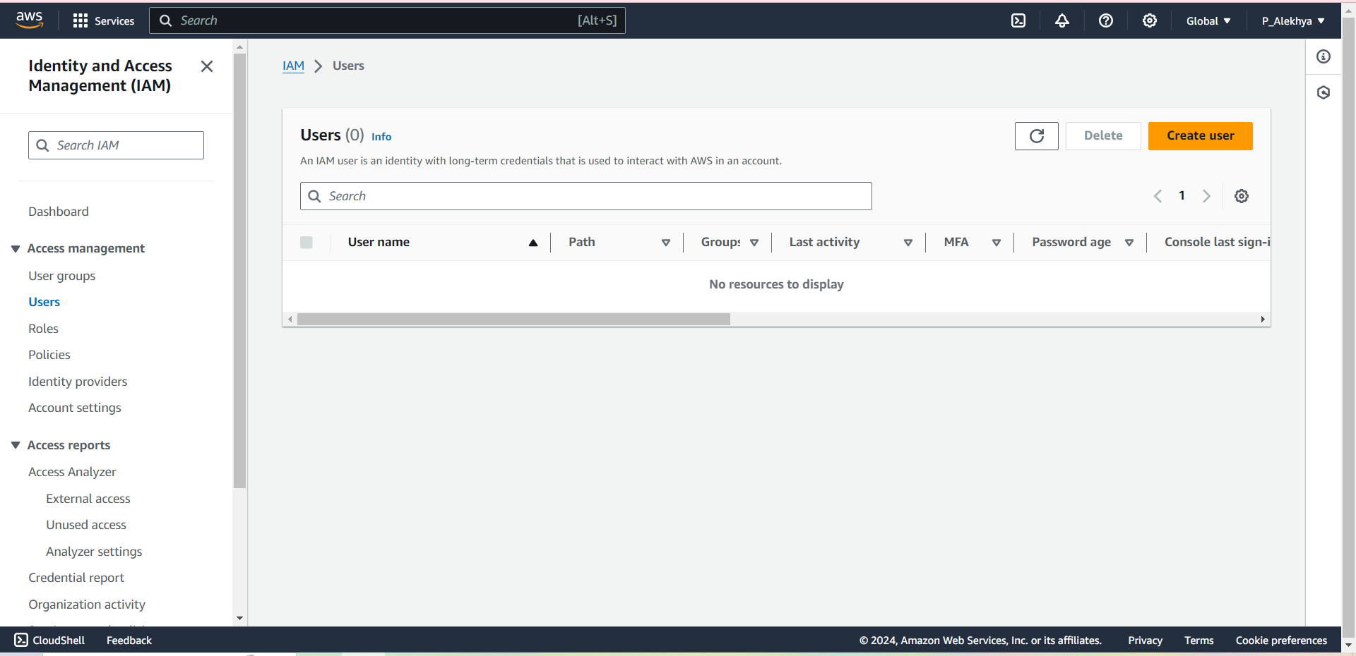

-The IAM Users dashboard, click on ‘create user’ to create an IAM User

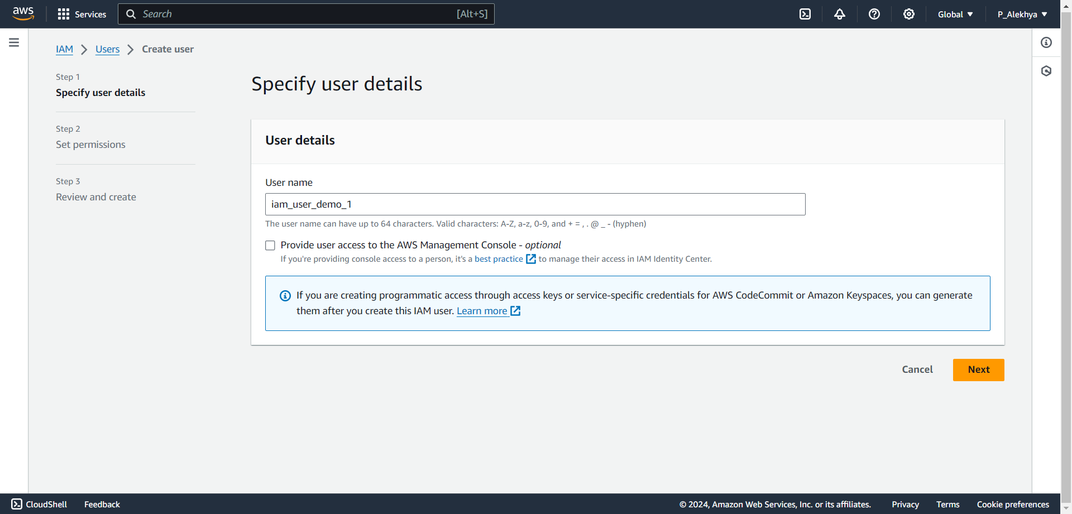

The "Specify user details" screen in AWS IAM, where a username is entered, and access to the AWS Management Console is optionally provided.

1. Check **"AWS Management Console access"** and choose **"IAM user"**.

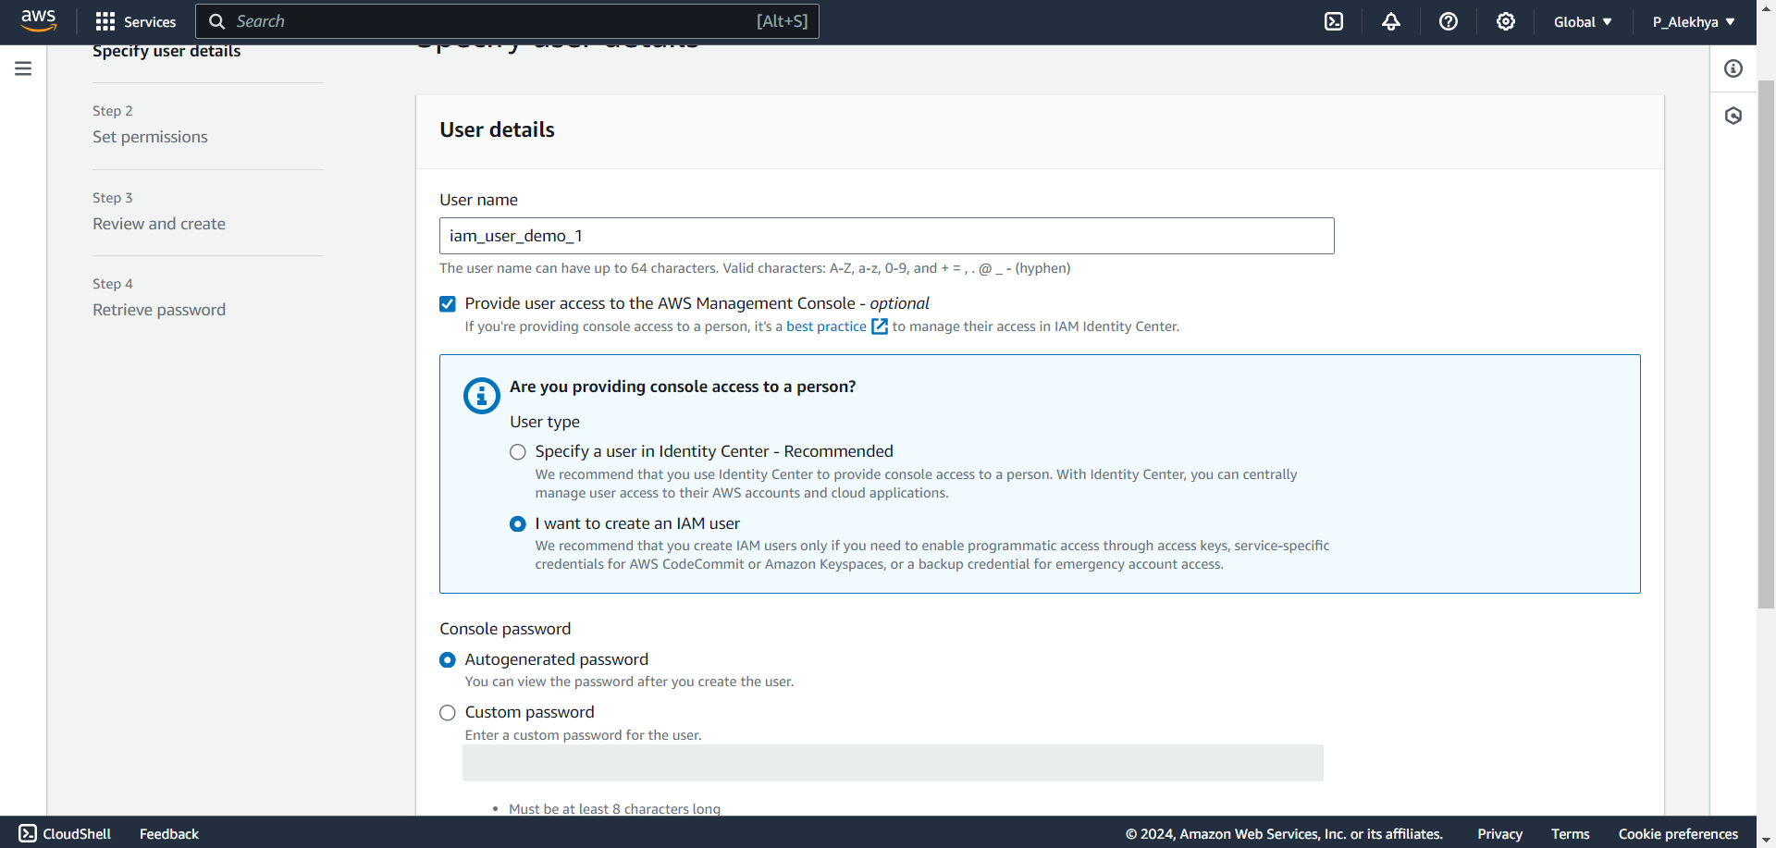

User type selection, where the choice is made between using AWS Identity Center or creating an IAM user. The IAM user option is selected.

1. Attach the **IAMUserChangePassword** permission policy.

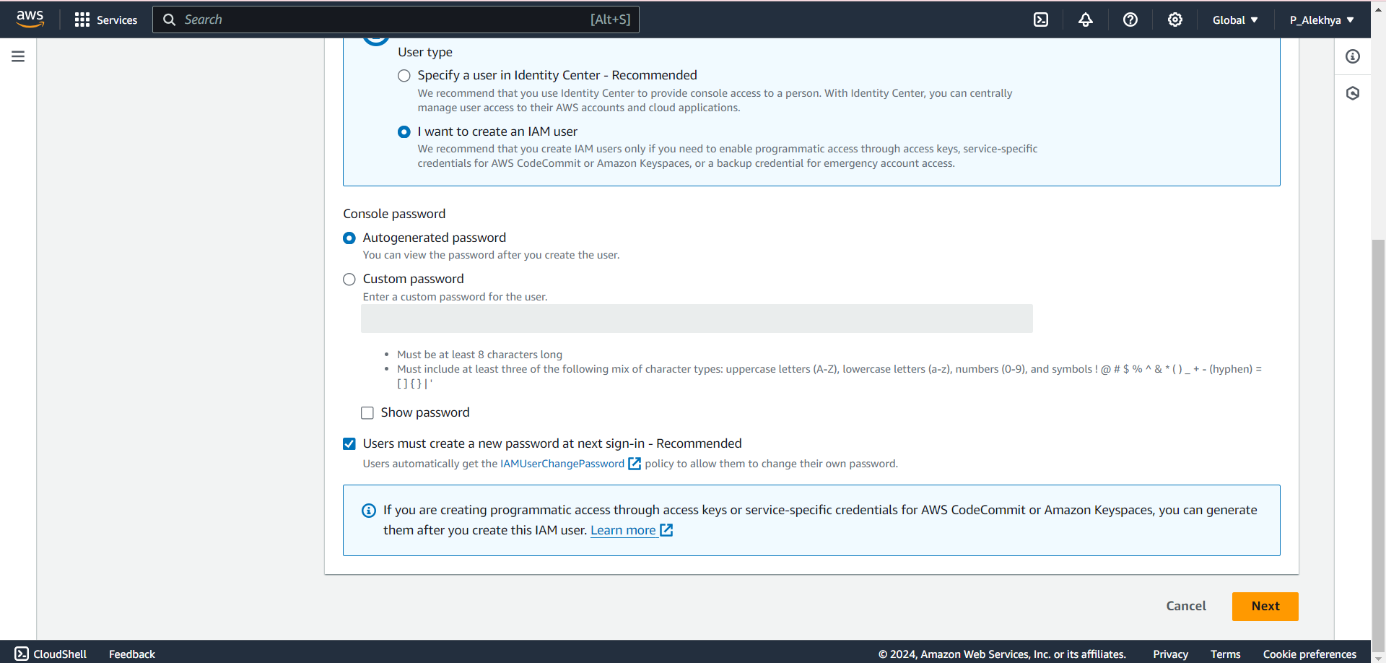

Screen shows the password options for the IAM user—either auto generated or custom—and the option to force a password reset on first sign-in.

1. Optionally, add tags for organization.

The "Set permissions" screen in IAM, where options are provided to add the user to a group, copy permissions, or attach policies directly to the user.

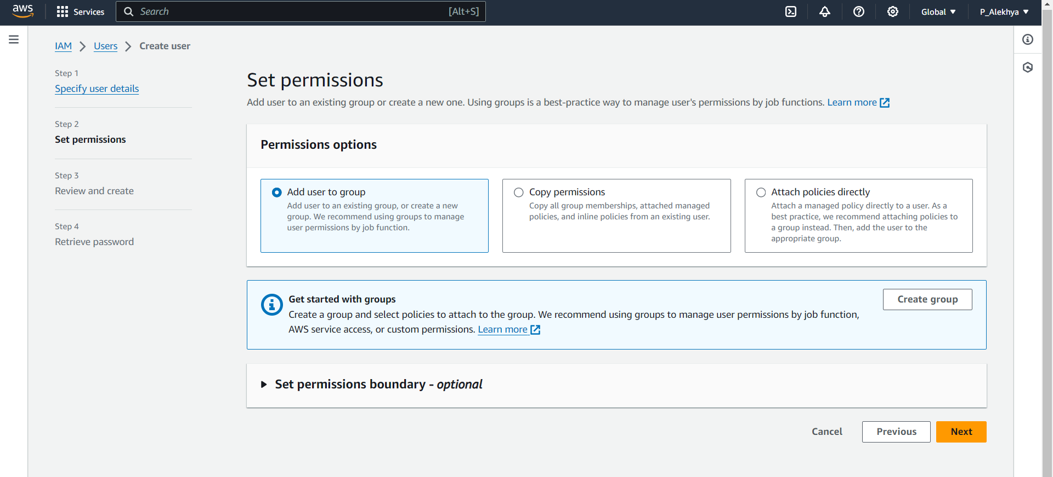

* If you want to add the user to a group, you can add them to an existing group or create a new group with a unique name,in this step which is optional.

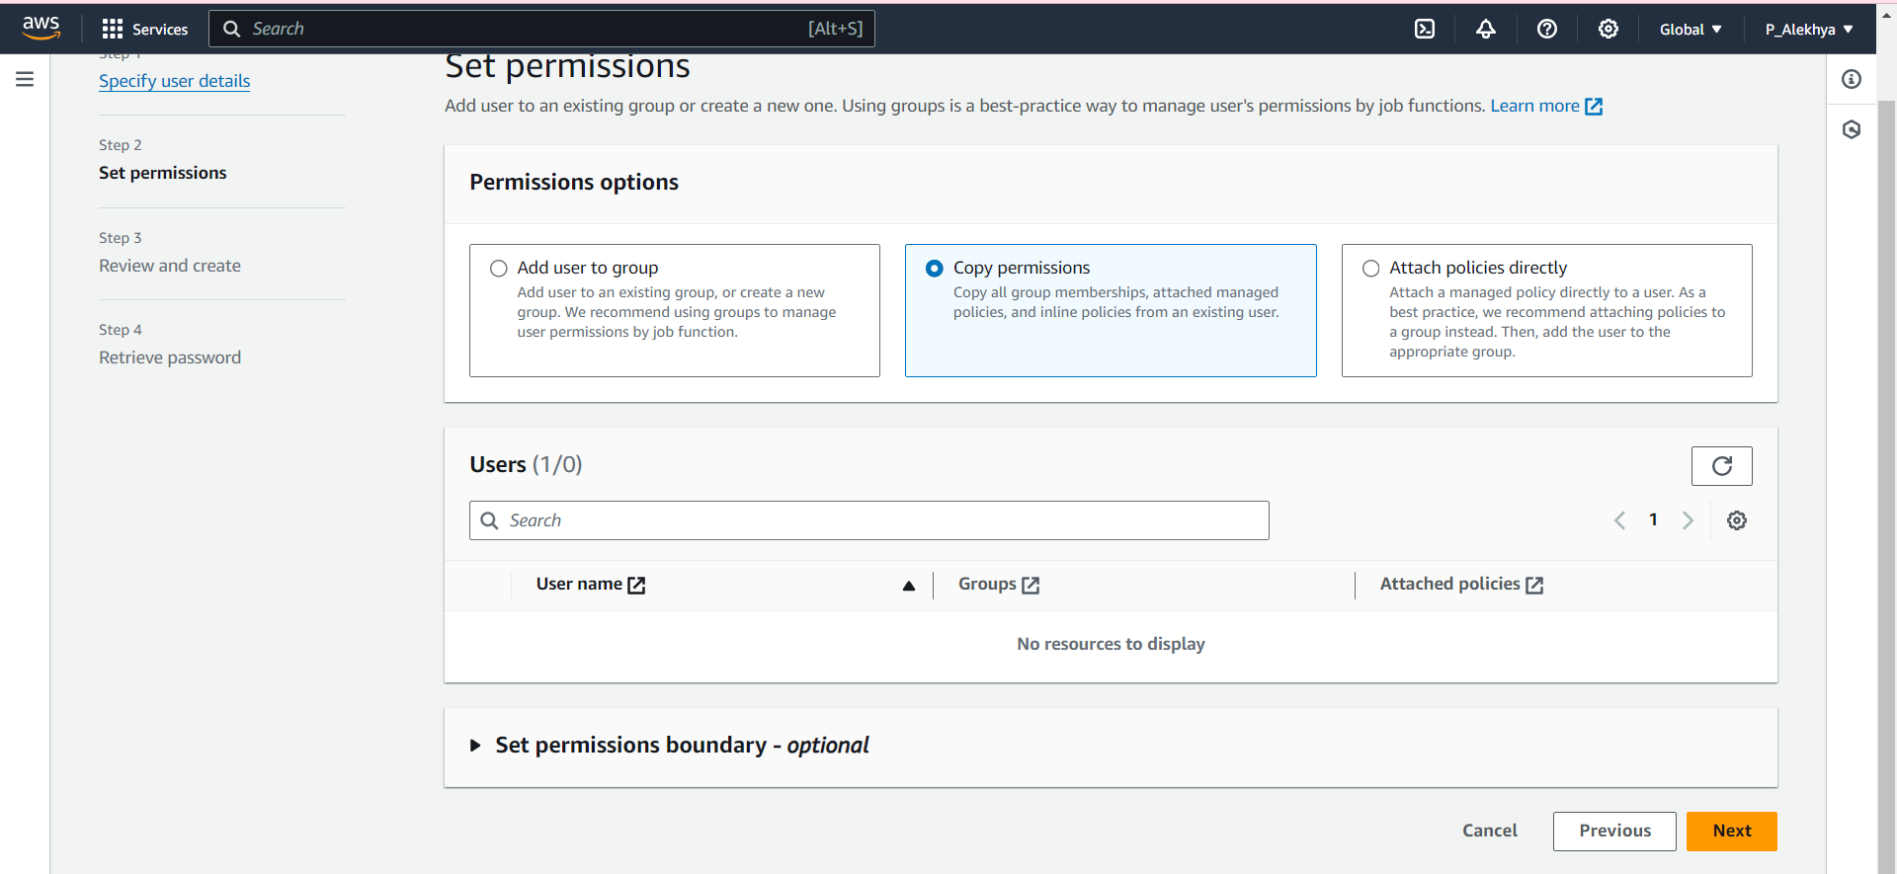

* Optional, allowing permissions from another user to be replicated

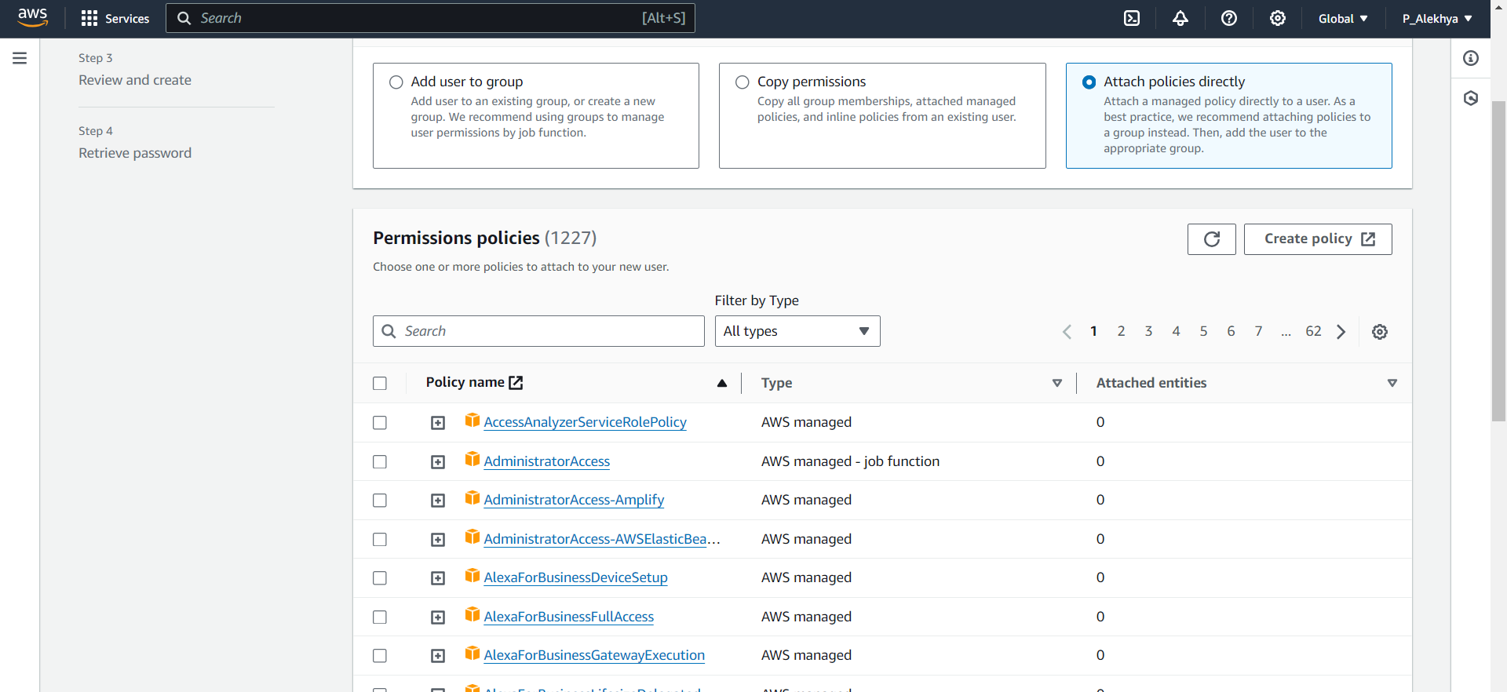

* Optional, In this step ,you can add services to the IAM User using search bar

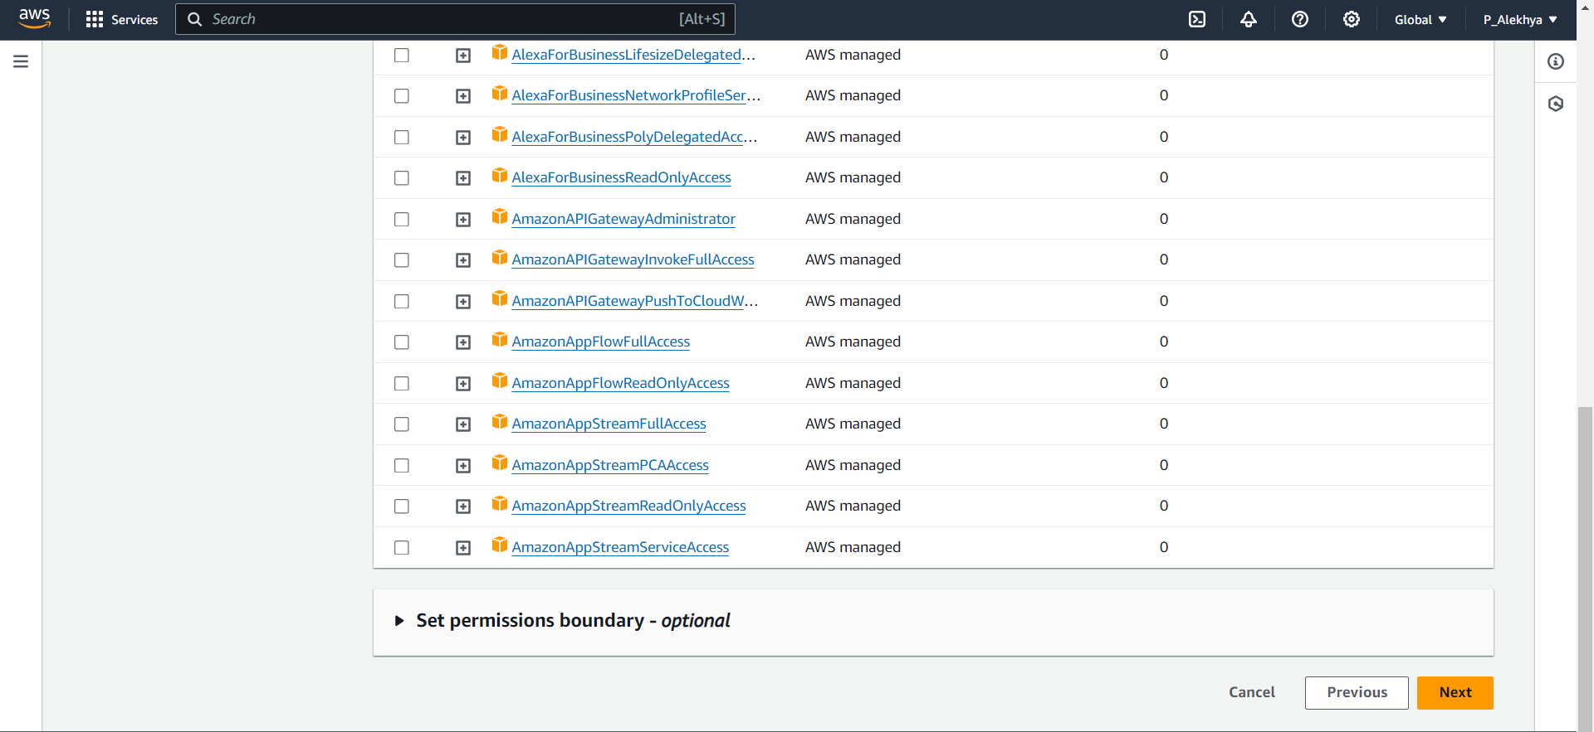

* And select ‘Next’.

1. Review the details and click **"Create user"**

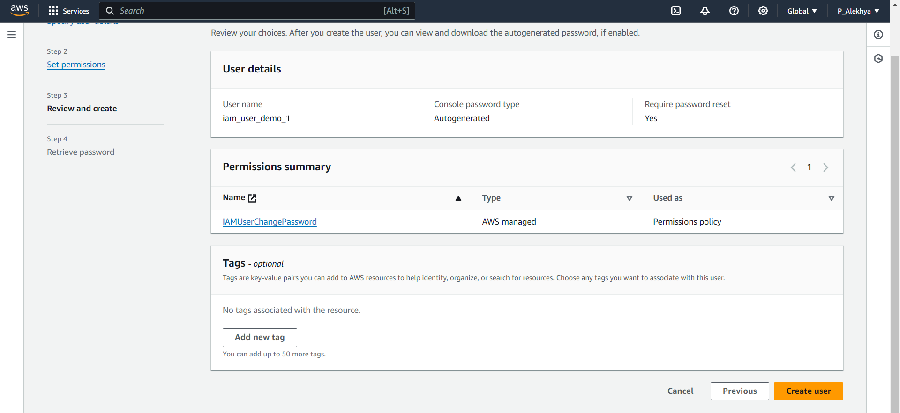

* Review the user details and permissions, then click on 'Create user' to create the user.

1. Retrieve login credentials and sign-in URL.

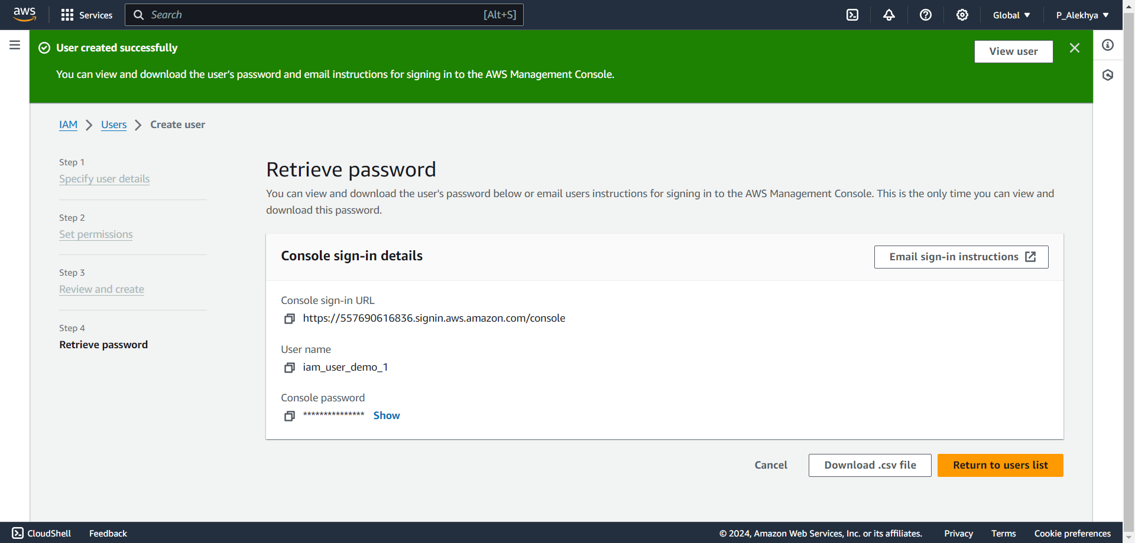

* Download the CSV file containing the user details and use the provided URL to log in to the IAM user account.

8.Log in as the user and confirm the ability to change the password.



* **Paste the provided URL into the browser's search bar to log in to the IAM user account.**

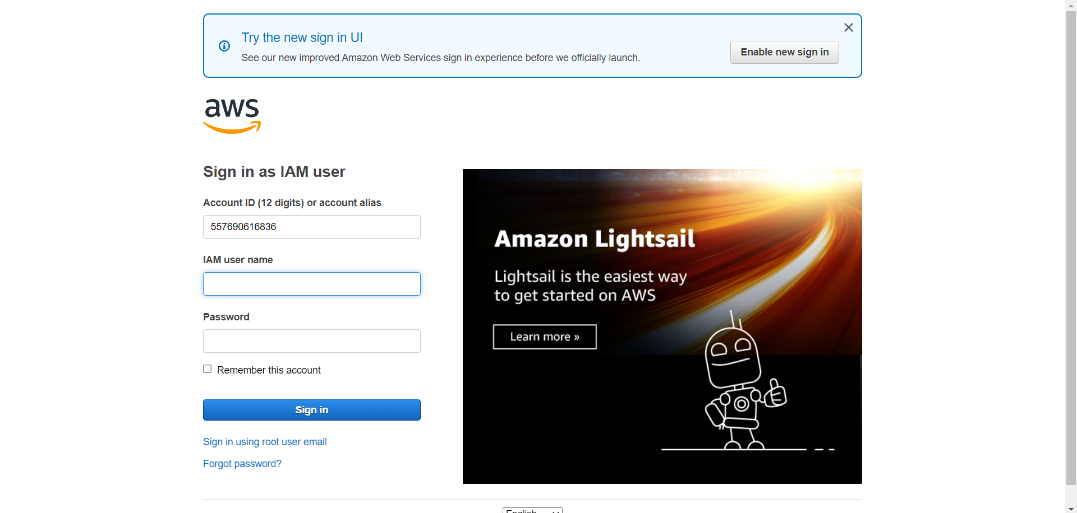

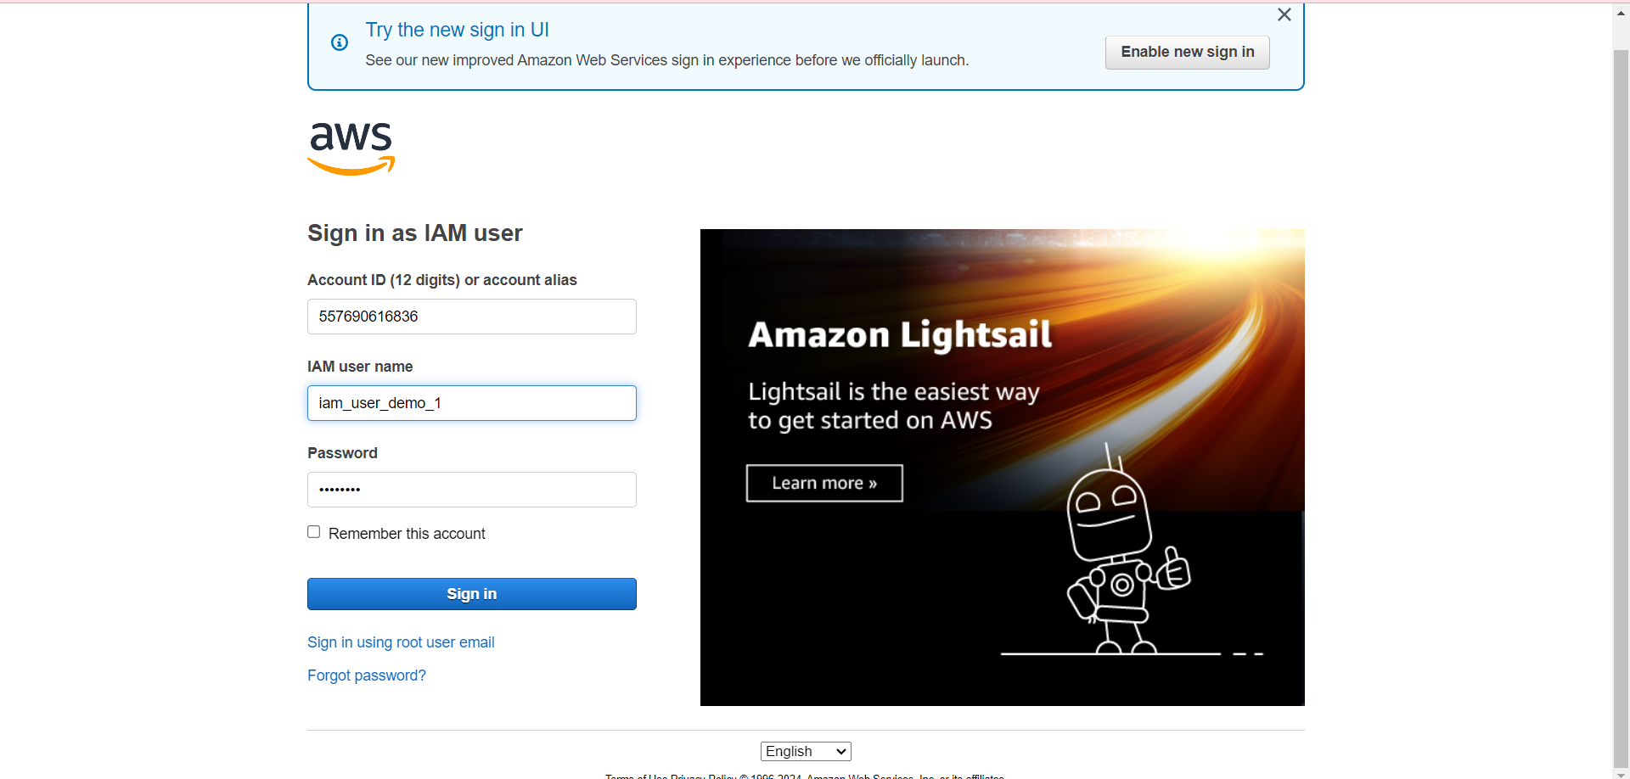

* **Enter your username and the given password to sign in.**
* **Change your password here and confirm it**

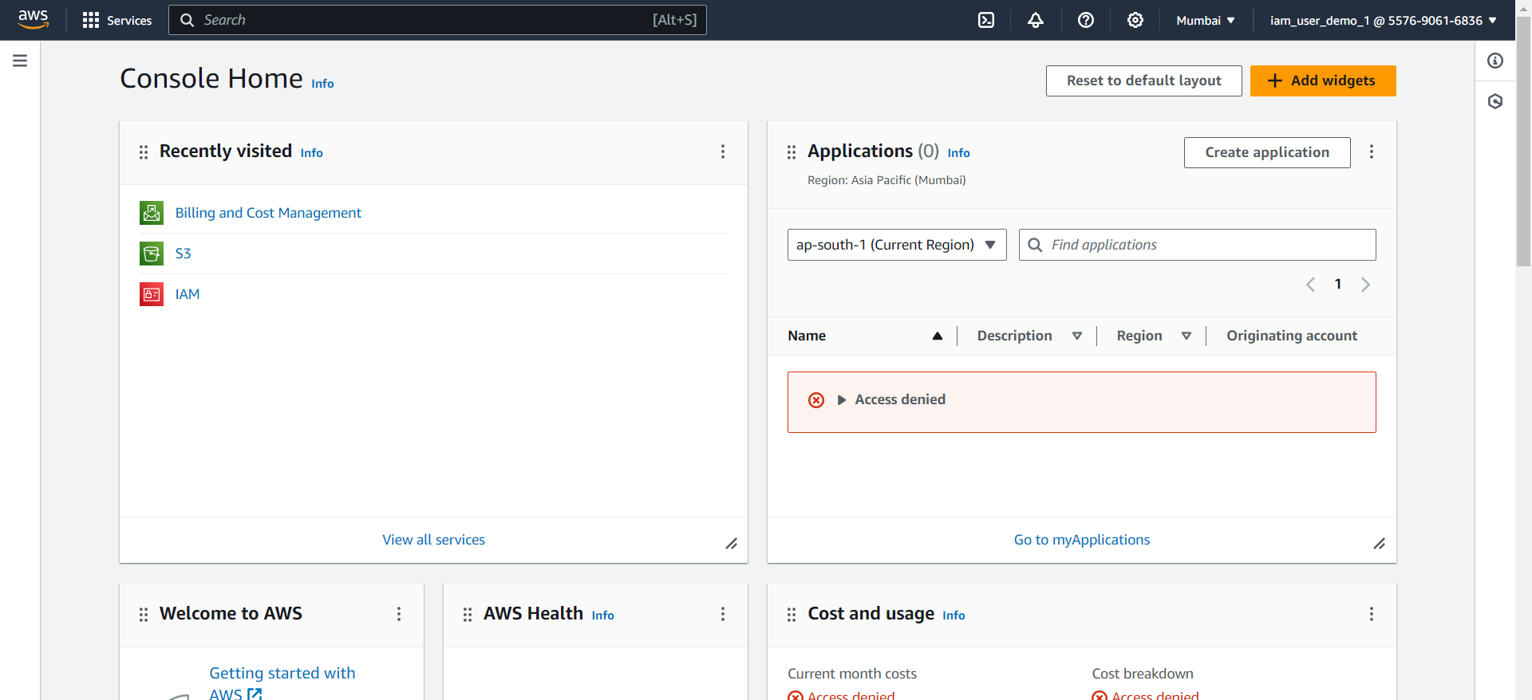

* **Successfully logged in to the IAM user account, where you can access the services that have been granted permissions. In this case, you have permission to change your password.**

**Conclusion:**

By implementing a streamlined process for creating an AWS IAM user with self-managed password capabilities, CloudX Solutions has enhanced security and control over critical cloud resources. This approach reduces administrative overhead, ensures compliance with security policies, and minimizes the risk of unauthorized access. By enforcing the principle of least privilege, the solution enables efficient management of user permissions while maintaining flexibility for future scalability. Overall, this project strengthens CloudX Solutions' security framework, supporting secure, efficient, and controlled cloud operations as the organization continues to grow and adapt to increasing demands.

4o